Student Name: __________________
Class and Section __________________
Total Points (10 pts) __________________
Due: January 14, 2011 before the class

Project: Servlets

CSCI 5520 Rapid Java Application Development
Armstrong Atlantic State University

Problem Description:

(Factorial table) Write a servlet to display a table that contains factorials for the numbers from 0 to 15. The following figure shows a sample run of the servlet that displays factorials for the numbers from 0 to 10.
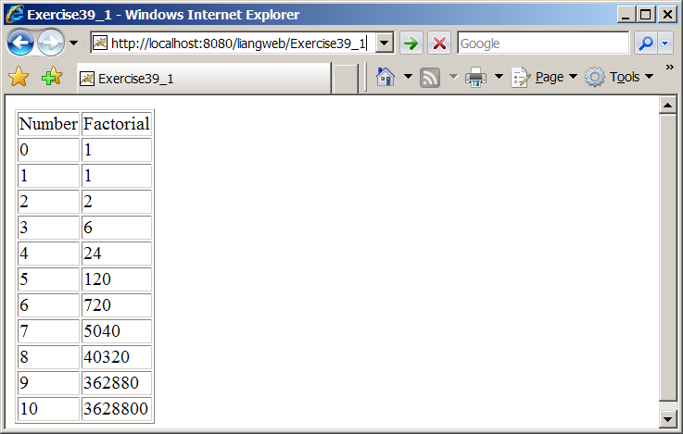

Name you servlet Exercise37_01.

Copy and paste Exercise37_01.java here:

Show a screen shot of your sample run

What to submit?

- Copy of this document.
- Save/Compile Exercise37_01.java on LiveLab. You may get compile errors, ignore them. Continue to submit it. I will enter a score later.

